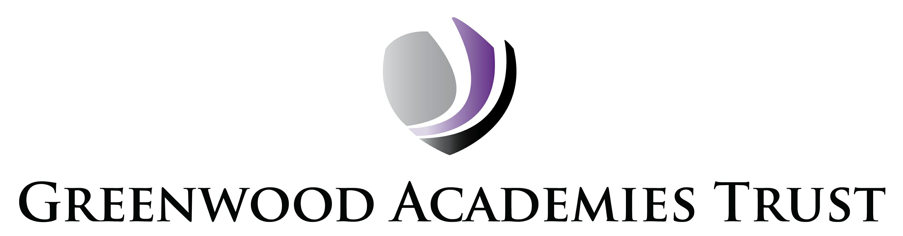

Photographs and Films

How we use your information

To comply with the General Data Protection Regulation (GDPR) 2018, we need to make you aware that from time to time we may photograph or film your child undertaking Academy activities. We may use the photographs or films either within the Academy and the Greenwood Academies Trust buildings (internally) or outside of the Academy and Trust buildings (externally).

The Academy may photograph your child for the purpose of identification in the Academy’s management information system. The Academy may also use photographs and film for monitoring or educational uses (eg curriculum subjects requiring video and photographs to be submitted to external examiners). The Academy does not require parental consent for these purposes as they are deemed to be public interest.

Pupils will always be made aware if they are being photographed / filmed, what the purpose of this is and will be given the opportunity to object.

Where the relevant consent has been obtained, photographs and films may be:

  - Used on displays, in presentations and in publications.
  - Used on the Virtual Learning Environment, websites and on social media sites which can be viewed throughout the world and not just in the United Kingdom where UK law applies.
  - Supplied to the media for use in newspapers and magazines and on TV, websites or social media sites such as Twitter or Facebook.
  - Used for monitoring or educational uses e.g. curriculum subjects requiring video and photographs to be submitted to external examiners.

- The full names (first name and surname) of pupils will not be disclosed without good reason and consent will be obtained for this.

- Pupil addresses will not be disclosed in detail, but we may state, for example, ‘Sally from Skegness’.

- Photographs and films will not be substantially edited, adapted or altered from their original intention or purpose, or used for anything which may be viewed as negative in tone or that may cause offence, embarrassment or distress.

- Copyright of all photographs and films belong to the Greenwood Academies Trust (GAT).

- Any reproduction or distribution of photographs or films by a third party will constitute an infringement of copyright without the written permission of the Trust and must be accompanied by a credit or by-line stating the authorship of the photographs or videos.

- Parents and pupils will be informed in advance if external parties, including the media, wish to photograph or film pupils and will be given the opportunity to object.

Please complete the form overleaf and return it to the Academy office.

PHOTO AND FILM PERMISSION FORM

Name of Student ……………………………………………… Year Group …………………….

I give my consent for the Academy/Greenwood Academies Trust (GAT) to use photographs and films of the above named child on the following social media platforms (please tick the appropriate box):
Yes No  Facebook | Yes No  Twitter | Yes No  Instagram
I give my consent for the Academy/Greenwood Academies Trust (GAT) to use photographs and films of the above named child in the following ways (please tick the appropriate box):
YES NO

On the Academy website

On the Trust website

In the Academy on wall displays

In any GAT promotional material (eg Academy prospectus)

In the Academy on TV screens

In the press

I have read and understood the information above and am signing this form as a parent, guardian or carer, who represents the student named above and his / her best interests.
I understand that it is my responsibility to notify the Academy if I change my mind about withdrawing or granting consent at any time in the future.

Name of Parent or Carer: ……………………………………………….......................................

Signature: ………………………………………………........... Date: ………………………………………...

