

Attendance Policy

Document Owner | Helena Bull
Version | 6.0
Effective From | February 25
Review Date | 1.9.2025

Introduction
Regular and punctual attendance at school is extremely important. Students need to attend the academy regularly if they are to take full advantage of the educational opportunities available to them by law. Purple Oaks Academy fully recognises its responsibilities to ensure students access learning available to them for the maximum number of days and hours.

Our policy applies to all children registered at this academy and this policy is made available to all parents/carers of students who are registered at our school and available on the website.

This policy has been written to adhere to the relevant Children Acts, Education Acts, Regulations and Guidance from the Department for Education, including working together to improve school attendance and in addition to guidance from the Local Authority.

Parents and carers have the legal responsibility for ensuring their child’s good attendance at school.
The staff at Purple Oaks Academy will work with families and other professionals and agencies to ensure that all students are encouraged and supported to develop good attendance habits.
Procedures in this policy are followed to ensure this happens.

Children who are persistently late or absent soon fall behind with their learning. Children who are absent from the academy, frequently develop large gaps in their learning which will impact on their progress and their ability to meet their targets.
Lateness can also impact on students’ ability to follow their morning schedule and feel settled and ready to learn.

If good attendance habits are not developed and valued the student will find it extremely difficult to hold onto a job when they are ready to be employed.

Aims and Objectives
This attendance policy ensures that all staff and families in our academy are fully aware of, and clear about, the actions necessary to promote good attendance.

Through this Policy we aim to:

- Promote a positive and welcoming atmosphere in which students feel safe, secure, and valued, and encourage in students a sense of their own responsibility.
- Support parents/carers to reduce barriers and support students to increase school attendance.
- Improve students’ achievement by ensuring high levels of attendance and punctuality.
- Achieve a minimum of 95% attendance for all children, apart from those with chronic health issues.
- Create an ethos in which good attendance and punctuality are recognised as the norm and seen to be valued by the academy.
- Ensure that our policy applies to Reception aged children and up to Post-16 to promote good habits
- Raise awareness to parents, carers and students of the importance of uninterrupted attendance and punctuality
- Work in partnership with students, parents, staff, and the School Attendance Support Team at the local authority (SAS) so that all students realise their potential, unhindered by unnecessary absence.
- Establish a pattern of early monitoring of attendance and ensure consistency in recognising achievement and support to overcome barriers.
- Recognise the key role of all staff, but especially class teams, in promoting good attendance.

Responsibilities
All members of academy staff have a responsibility for identifying trends in attendance and punctuality.
The following are expectations of Parents and Carers and Purple Oaks Academy. More detailed responsibilities can be found in Appendix 1.
Parents/carers are expected to: | The Academy is expected to:
- Ensure their child attends every day the school is open except when a statutory reason apply  - Contacting the academy office on the first morning of absence and daily thereafter (01604 434471)  - Book any medical appointments around the school day where possible. Written evidence (screen shots of texts/letters from the hospital, appointment cards) will be requested and kept on file. When informing the academy of a medical appointment written evidence will be requested as standard.  - Informing the academy in advance of any medical appointments in academy time.  - Only making requests for authorised absence during term time in exceptional circumstances and in advance in writing to the Principal.  - Work with the school and local authority to help parents/carers understand their child’s barriers to daily attendance at school.  - Proactively engage with the support offered to prevent the need for more formal support. | - Have a clear school attendance policy on the school website which all staff, students and parents understand.  - Develop and maintain a whole school culture that promotes the benefits of good attendance. Including staff modelling good attendance.  - Maintain the same ambition for attendance and work with students and parents to maximise attendance.  - Accurately complete admission and attendance registers morning and afternoon.  - Have robust daily processes to follow up absence. Have a dedicated senior leader with overall responsibility for championing and improving attendance. (see Appendix 2)  - To make a referral to the SASS (School Attendance Support Service) should attendance be deemed irregular.  Attendance Champion: Helena Bull (Deputy Principal and DSL)  - Proactively use data to identify pupils at risk of poor attendance.  - Work with each identified student and their parents to understand and address the reasons for absence, including any in-school barriers to attendance.  - Where out of school barriers are identified, signpost and support access to any required services in the first instance. If the issue persists, take an active part in the multi-agency effort with the local authority and other partners. Act as the lead practitioner where all partners agree that the school is the best placed lead service. Where the lead practitioner is outside of the school, continue to work with the local authority and partners.  - Where there is a lack of engagement, hold more formal conversations with parents and be clear about the potential need for legal intervention in future.  - Where support is not working, being engaged with or appropriate, work with the local authority on legal intervention.  - Where there are safeguarding concerns, intensify support through statutory children’s social care.  - Work with other schools in the local area, such as schools previously attended and the schools of any siblings.  - If social workers are involved inform the student’s social worker if there are any unexplained absences and if their name is to be deleted from the register.

Definitions

Authorised absence
- An absence is classified as authorised when a child has been away from the academy for a legitimate reason and the academy has received notification from a parent or carer. For example, if a child has been unwell and the parent telephones the academy to explain the absence.
- Only the academy can authorise absence. Parents do not have this authority. Consequently, not all absences supported by parents will be classified as authorised.

Unauthorised absence
- An absence is classified as unauthorised when a child is away from academy without the permission of the academy, this could be an unauthorised holiday or other unexplained absence taking place in term time.
- Term time holidays will not be authorised. Absence is only authorised during term time by the Principal in exceptional circumstances, at the discretion of the Principal.

Irregular Attendance
- Irregular attendance - this is, generally, a longer series of short absences where there has been an unsatisfactory explanation for the absence, or no reason provided

We expect every child to have at least 95% attendance.
However, if you take your child out of school for an accumulative total of 5 days or more (10 sessions) (90%) over a period of 10 weeks, the school will deem this as irregular attendance and will consider a referral to the Local authority for consideration of legal action.
This could include:
- a Penalty Notice payable up to £160 fine
- prosecution under s444 (1) Education Act 1996, where if convicted you may be fined up to £1,000
- prosecution under s444 (1) (a) Education Act 1996 where if convicted you may be fined up to £2,500 and/or 3 months’ imprisonment

Registration
The Academy doors open at 8.45 am and remain open until 9am.
Staff are always on hand to speak to parents/carers should the need arise at this time, please speak to the office who will contact the class team for you.

Each class teacher has the responsibility for keeping an accurate record of attendance. Any student who is absent must be recorded at the beginning of the morning and afternoon session. The attendance registers on Arbor must be completed by the class teacher by 9.10 am and by 1.10pm. (Attendance code / and \ for students who are present).

All attendance records are documented using Arbor software, which is supported by the Local Authority and the Trust. Attendance registers are legal documents, and these must be kept secure and preserved for a period of three years after the date they were last used.

Lateness
Once the gates/doors are closed at 9am, the only way to get into academy is via the academy office at the front of the building. Any student who comes into academy this way from 9am will be marked as late before the register closes in the attendance record. If a student arrives after 9.15am then the student will be marked late after the register closes.
When a student is late, parents/carers will need to sign their child into the academy using the sign in screen within the office. The office staff will ask for a reason and this will be recorded on the attendance system, parents/carers may be asked for written evidence. Lateness is monitored and will be addressed should it become a regular occurrence so that it does not become a habit.

Procedure for late students

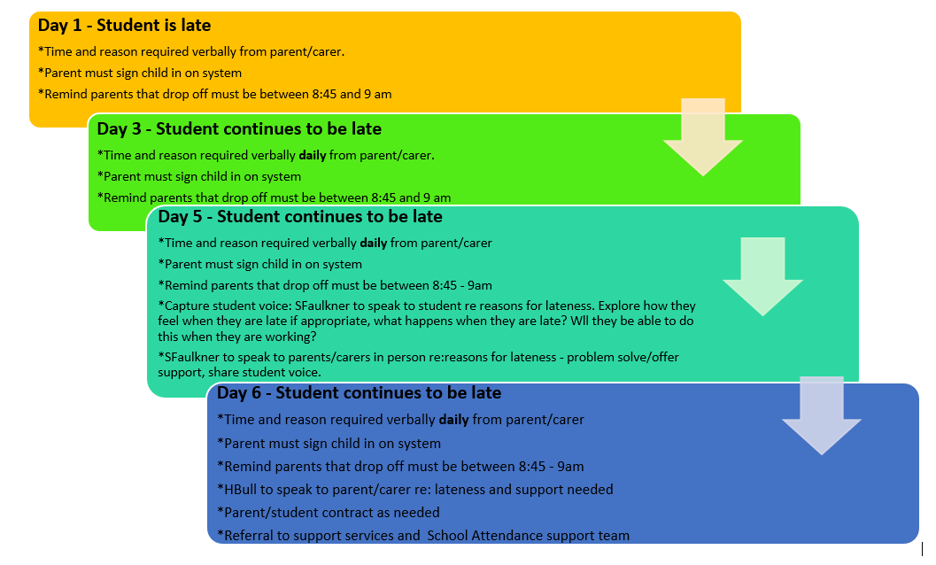

Persistent lateness
Children who are persistently late miss a significant amount of learning, often the most important aspect, as the beginning of the day is where the student can organise themselves and the teacher explains the learning for the day and what each child is expected to achieve.

Where there have been persistent incidents of lateness parents/carers will be invited to speak with the Learning Mentor for Families (Sharon Faulkner) to look at barriers and how we can improve punctuality. Sharon will also speak with the student to gain their view and seek to support them to improve their persistent lateness.
If the lateness still does not improve then parents and carers will be invited to speak with the Deputy Principal, Helena Bull, to look at support and actions needed.

Early Pick-Ups
Equally, if there are persistent incidents of parents picking up early (before 3pm) then this will be addressed. Persistent early pick up is not acceptable and will not be authorised. Parents will be offered support from Sharon Faulkner to identify and support to resolve the barriers to the child completing their full school day.

Attending medical appointments
We would encourage parents/carers to make medical/dentist appointments outside of the school day wherever possible. We appreciate this is not always possible, but we would ask that you look to book appointments at the beginning or end of the school day so that students are still able to access the school day and come in before or after the appointment.
Children who have attended a dentist or doctor’s appointment and subsequently come to academy later than 9.05am will have the absence recorded as a medical absence (Attendance code M) but medical evidence must be provided, such as an appointment letter or screen shot of a text message which will be added to Arbor for our records.

ABSENCES
Parents/carers should contact the academy on the first day of their child’s absence, giving the child’s name, class and reason for absence.
All absences are recorded as either authorised or unauthorised. It is important that the Academy receive accurate, detailed information from parents and carers with reasons for the child’s absence. This information is used to determine whether the absence is authorised or unauthorised. The Principal has the discretion to determine whether absences are authorised or unauthorised.

First Day Contact
Where a child is absent from academy and we have not received any verbal reason from the parent, then we will initiate a first day contact process. The Student and Families Learning Mentor/Admin staff check all class registers from 9.00am to 9.20am on a daily basis, to identify those students who are absent. There are occasions when we are unaware of a reason for the absence, and we will always contact the parent/carer to check the reasons for the child’s absence. If we cannot make contact we will aim to contact second/third contacts or make a home visit to check on the welfare of the child. Likewise, if a student has been absent from school for 4 days in a week, on the 5th day a home visit will made by the pastoral team, even if a parent/carer has called in every day.

Illness
If the absence is likely to continue for an extended period, or be a repetitive absence, the academy will initially provide learning materials to enable the student to continue their education. The academy will also contact the support services to see if arrangements can be made for the child to be given some home tuition outside of the academy.

If your child has had a period of illness for 3 or more days, we would encourage you to seek support from medical professionals. In this instance we may request to see medical evidence.

Term time holidays

As school attendance is important, we would encourage parents and carers not to book term time holidays.
School is open to students 190 days per year, this leaves 170 days (including weekends) to book holidays in.

With effect from September 2013 the government abolished the right of Headteachers and Principals to authorise absence, specifically for term time holidays. Instead, Principals will only be allowed to grant leave of absence for any reason if they are satisfied exceptional circumstances apply. If this is the case then leave of absence will need to be in writing to the Principal and sent in advance to the Principal for consideration.
The Principal’s email address is mhansraj@purpleoaksacademy.org

However, if you take your child out of school for an accumulative total of 5 days or more (10 sessions) (90%) over a period of 10 weeks, the school will deem this as irregular attendance and will consider a referral to the Local authority for consideration of legal action.
This could include:
- a Penalty Notice payable up to £160 fine
- prosecution under s444 (1) Education Act 1996, where if convicted you may be fined up to £1,000
- prosecution under s444 (1) (a) Education Act 1996 where if convicted you may be fined up to £2,500 and/or 3 months’ imprisonment

Addressing Attendance Concerns
The academy expects attendance of at least 95% for all students.

It is important for children to establish excellent attendance habits early on in their school career. It is the responsibility of the all the parents and carers and academy staff to support good attendance and to identify and address attendance concerns promptly.

At all ages we rely upon parents and carers to ensure their child attends the academy regularly and punctually and therefore, where there are concerns regarding attendance parents/carers are always informed of these concerns and encouraged to work our pastoral team to increase attendance.
Initial concerns about attendance are raised with parents and carers via face-to-face conversations to understand the barriers to good attendance and enable support to be implemented.
If this support has not increased attendance, then a more formal plan may need to be implemented in the form of a parenting contract or Education Supervision order. This may also mean that it be necessary to involve statutory Children’s social care. This could then lead to prosecution if attendance does not improve.

The School Attendance and Support Service (SASS)can seek to issue penalty notices to parents where there has been support implemented and attendance at school has not increased.

Appendix 1: Detailed Responsibilities
Class teachers are expected to: | Learning Mentor (for Families) and Admin are expected to: | The Principal and Dedicated Senior champion (Helena Bull) are expected to:
- Modelling promptness and good attendance themselves.  - Emphasising with their class the importance of good attendance and promptness.  - Following up absences with immediate requests for explanation which should be recorded on CPOMS alerting the DSL’s.  - Keeping an overview of class and individual attendance looking particularly for either poor overall attendance, anomalies in patterns of attendance and/ or unusual explanations for attendance offered by children and their parents/ carers  - Informing the Attendance team where there are concerns and acting upon advice  - Providing background information to support referrals should the need arise.  - Monitoring follow-up once actions have been taken to correct attendance concerns  - Discussing attendance issues at consultation evenings where necessary | - * Collating and recording registration and attendance information  - * Taking and recording messages from parents regarding absence  - * Ensuring the Reason for absence/ late file/Teams channel is completed am and pm  - *Recording details of children who arrive late or go home early  - *Sending out standard letters regarding attendance following protocol.  - *Conduct home visits where necessary  - *LM (Families) Keeping an overview of class and individual attendance looking particularly for either poor overall attendance, anomalies in patterns of attendance and/ or unusual explanations for attendance  - *LM (Families) Meeting with families, where identified concerns have been raised to discuss how the school can support and understand the barriers to good attendance.  - *LM (Families) Support parents/carers to ensure every child has good attendance and ensure full access to the academy day. | - *Monitor whole academy attendance  - *Identify trends in authorised and unauthorised absence for individuals and identified groups  - *Contact families where concerns have continued to be raised about absence including arranging meetings to discuss attendance issues  - *Monitor individual or identified group attendance where concerns have been raised  - * Make referrals to the School Attendance Support Team (SAS). Liaise with the school attendance support team (SAS) help improve the students attendance.  - *Provide reports and background information to inform discussion with the School Attendance and support team (SAS).  - *Liaise with other professionals to determine potential sources of difficulties and reasons for absence.  - *Report to the Academy Council, Local Authority and Greenwood Academies Trust Board as needed.

First Day Response Protocol:


