EYFS Long Term Plan - CYCLE A
 | Term 1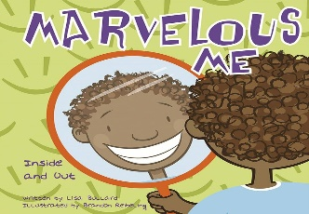 | Term 2 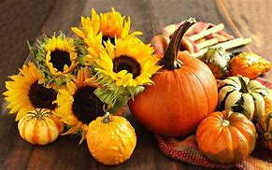 | 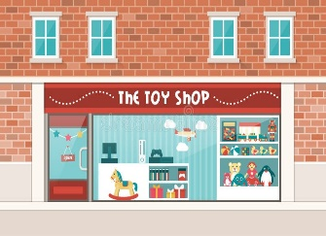  Term 3 | Term 4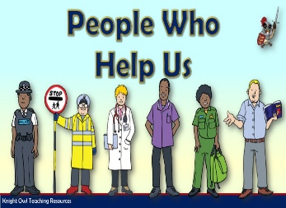 | Term 5 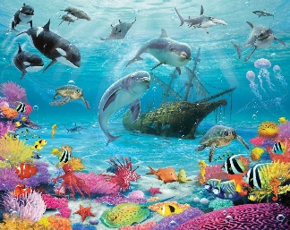 | Term 6 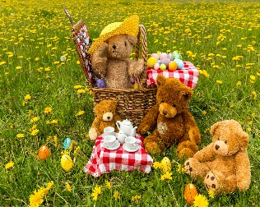
Theme | Theme: Marvellous Me and My Senses. | Theme: Autumn Harvest | Theme: Toys | Theme: People who help us | Theme: Under the Sea | Theme: Teddy Bears Picnic
Early Years Foundation Stage Areas of learning | Communication and Language –  PLG  Themed vocabulary  Colourful Semantics-Who | Communication and Language –  PLG  Themed vocabulary  Colourful Semantics-Who | Communication and Language –  PLG  Themed vocabulary  Colourful Semantics-What | Communication and Language –  PLG  Themed vocabulary  Colourful Semantics-What | Communication and Language –  PLG  Themed vocabulary  Colourful Semantics-Where | Communication and Language –  PLG  Themed vocabulary  Colourful Semantics-Where
Early Years Foundation Stage Areas of learning | Literacy, phonics  See long term plans – Read, Write Inc  Stories  Non-fiction  Rhymes  Poems | Literacy, phonics  See long term plans – Read, Write Inc  Stories  Non-fiction  Rhymes  Poems | Literacy, phonics  See long term plans – Read, Write Inc  Stories  Non-fiction  Rhymes  Poems | Literacy, phonics  See long term plans – Read, Write Inc  Stories  Non-fiction  Rhymes  Poems | Literacy, phonics  See long term plans – Read, Write Inc  Stories  Non-fiction  Rhymes  Poems | Literacy, phonics  See long term plans – Read, Write Inc  Stories  Non-fiction  Rhymes  Poems
Early Years Foundation Stage Areas of learning | Recommended Texts  Marvellous Me, Inside and Out In my heart  Nursery Rhymes/ Rhyming words  Hug  Spreading my wings (C&D)  I love me (C&D) | Recommended Texts  The Tiny Seed  Pumpkin Soup  A walk in Autumn  Autumn Allen Busby | Recommended Texts  Toy Story | Recommended Texts  Busy People Police Officer  Busy People Fire Fighter  Busy People Doctor  Busy People Teacher | Recommended Texts  Commotion in the Ocean  That’s not my Turtle  Tip Tap went the Crab  Sharing a Shell | Recommended Texts  We are going on a picnic  Where’s Teddy  We’re Going to a Birthday Party  The Teddy Bears Picnic  Goldilocks and the Three Bears
Early Years Foundation Stage Areas of learning | Mathematics  See long term plan – White Rose Maths | Mathematics  See long term plan – White Rose Maths | Mathematics  See long term plan – White Rose Maths | Mathematics  See long term plan – White Rose Maths | Mathematics  See long term plan – White Rose Maths | Mathematics  See long term plan – White Rose Maths
Early Years Foundation Stage Areas of learning | PSED  Sense of Self  My Family | PSED  Recognising and celebrating differences in people | PSED  Friendships  Sharing | PSE  Asking for help | PSED  Being Safe | PSED  Healthy Eating
Early Years Foundation Stage Areas of learning | Physical Development  Games  Ball Skills: Throwing, catching,  Fine and Gross Motor Skills: Dough Disco | Physical Development  Gymnastics  Balance  Coordination  Fine and Gross Motor Skills: Dough Disco  Interoception | Physical Development  Dance  Developing basic movement skills  Fine and Gross Motor Skills: Dough Disco  Interoception | Physical Development  Games  Ball Skills: Aiming, kicking, passing  Fine and Gross Motor Skills: Dough Disco  Interoception | Physical Development  Gymnastics  Fine and Gross Motor Skills: Dough Disco  Interoception | Physical Development  Dance  Establishing rhyme and timing  Fine and Gross Motor Skills: Dough Disco  Interoception
Early Years Foundation Stage Areas of learning | Understanding the World  My Senses *Interoception  All about me | Understanding the World  The Natural World  Seasons | Understanding the World  Toys Then and Now  Old and New | Understanding the World  People who help me | Understanding the World  Protecting our oceans - recycling | Understanding the World  My community
Early Years Foundation Stage Areas of learning | Expressive Arts and Design  Materials Inside  Music - Charanga  Anyone Can Play  Unit 1  Introducing Instruments | Expressive Arts and Design  Mark Making  Music – Charanga  Anyone Can Play  Unit 2  Exploring Instruments | Expressive Arts and Design  Colour  Music – Charanga  Anyone Can Play  Unit 3  Choosing Instruments | Expressive Arts and Design  Materials Outside  Music – Charanga  Anyone Can Play  Unit 4  Introducing Sway | Expressive Arts and Design  Mark Making  Music – Charanga  Anyone Can Play  Unit 5  Introducing March | Expressive Arts and Design  Colour mixing  Music – Charanga  Anyone Can Play  Unit 6  Introducing Loud and Quiet
Trips and Enrichment | My home  My school | Visit Santa’s Wonderland |  |  | Visit local fish/Pets at home | Attend a local park for a picnic
Department/ Whole School Opportunities | Celebrating differences in our favourite things (class/department based) | Harvest Festival  Christmas productions  Backwards Christmas Calendar | Stay and play | Public service vehicle visit  Dress up as someone who helps us/you
Cultural capital and RE | Diwali Celebrations of Lights | Christianity at  Christmas | World Religion Day – to be celebrated on 19th January 2026 | Faith Day (Eid)
Cultural capital and RE | Religious education and cultural capital will be explored through the schools broad and balanced curriculum themes, PSHE/RE and preparation for adulthood curriculum and assemblies.  The school will participate in national schemes such a world religion day and Inter Faith weeks, where it is deemed appropriate and accessible to learners.  The school will use and adapt West Northamptonshire’s agreed Religious Education syllabus ‘Growing Together’.

