KS3 Thematic Curriculum - Pathway 1 and 2

Cycle A | Term1 | Term2 | Term3 | Term 4 | Term 5 | Term 6
Theme | Me, Myself and I   | Winter Warmer  | Charity Champions | Help! Public Services 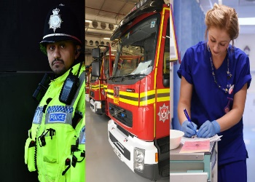 | Market Town Towcester  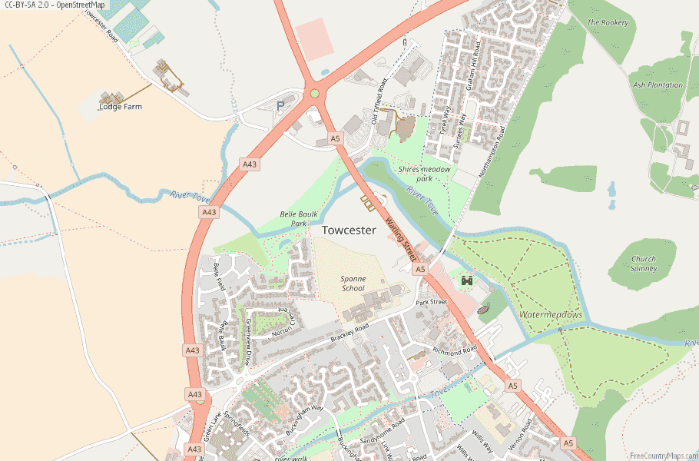 | Great Britain 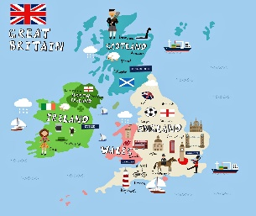
Core Curriculum Subjects | Mathematics  See long term plan – White Rose Maths | Mathematics  WRM | Mathematics  WRM | Mathematics  WRM | Mathematics  WRM | Mathematics  WRM
Core Curriculum Subjects | English, phonics, and communication  See long term plans – Read, Write Inc | English, phonics, and communication  See long term plans – Read, Write Inc | English, phonics, and communication  See long term plans – Read, Write Inc | English, phonics, and communication  See long term plans – Read, Write Inc | English, phonics, and communication  See long term plans – Read, Write Inc | Englis, phonics, and communication  See long term plans – Read, Write Inc
Thematic Curriculum | Creative Arts  Portraits  Master Techniques in Drawing  Paper  Master Practical Skills in Using Materials | Creative Arts  Winter Collage  Master Techniques in Collage  Weaving  Mastering Practical Skills in Textiles | Creative Arts  Sculpture  Master Techniques in Sculpture  Master Practical Skills in Construction and Mechanics | Creative Arts  Famous Artists  Master Techniques in Painting  Upcycling  Master Practical Skills in Textiles | Creative Arts  Natural Materials  Master Techniques in Printing  Food Prep  Mastering skills in Food Preparations | Creative Arts  Pop Art  Master Techniques in Drawing  Design  Make, Evaluate and Improve
Thematic Curriculum | Scientific Technologies  Healthy Humans | Scientific Technologies  Everyday Materials | Scientific Technologies  Plants | Scientific Technologies  Materials (States of Matter) | Scientific Technologies  Living Things and their Habitats | Scientific Technologies  Introduction to Light, Force and Sound
Thematic Curriculum | Computing Technology and Inclusivity  See long term plans – Teach computing | Computing Technology and Inclusivity  See long term plans – Teach computing | Computing Technology and Inclusivity  See long term plans – Teach computing | Computing Technology and Inclusivity  See long term plans – Teach computing | Computing Technology and Inclusivity  See long term plans – Teach computing | Computing Technology and Inclusivity  See long term plans – Teach computing
Thematic Curriculum | Food Technology  Practical Skill:  Weigh and measure  Method: Bake  Food Hygiene | Food Technology  Practical Skills:  Blitz, crush and grate  Method: Fry  Food Hygiene | Food Technology  Practical Skills  Knife Skills – Slice, cut, chop and trim  Method: Stir-fry, grill  Food Hygiene | Food Technology  Practical Skills:  Peel, drain, zest  Method: Boil and simmer  Food Hygiene | Food Technology  Practical Skill:  Mix and Fold  Rub-in  Method: Bake  Food Hygiene | Food Technology  Practical Skill:  Layer  Shape  Method: Bake  Food Hygiene
Subject Centred Curriculum | Geography | Geography | Geography  Compare Locations Overseas  Investigating Places | Geography | Geography  Local Environment  Communicate Geographically | Geography  Natural and Manmade  Investigate Pattern
Subject Centred Curriculum | History  Understand Chronology | History  Connections in World History | History | History  Investigate and Interpret Evidence | History | History
Subject Centred Curriculum | PSHE/RSE -PSHE Association  Self-Awareness | PSHE/RSE – PSHE Association  Self-Care, Support and Safety | PSHE/RSE – PSHE Association  Managing Feelings | PSHE/RSE – PSHE Association  Changing and Growing | PSHE/RSE – PSHE Association  Healthy Lifestyles | PSHE/RSE – PSHE Association  The World I Live In
Subject Centred Curriculum | Music –Charanga | Music – Charanga | Music – Charanga | Music – Charanga | Music – Charanga | Music – Charanga
Subject Centred Curriculum | Movement and Physical Education  Gymnastics | Movement and Physical Education  Games: Tennis | Movement and Physical Education  Dance | Movement and Physical Education  Net Games | Movement and Physical Education  Gymnastics | Movement and Physical Education  Games
Careers and Enterprise | Careers  GB1 | Enterprise: Christmas Fayre | Careers  GB3 | Enterprise: Easter Fayre | Careers  GB4 | Enterprise: Summer Fayre
My Community (Trips and Enrichment) |  |  | Visit a local charity (preferably the one we donated to at Christmas) | Visit local public service centres | Towcester Country Park
Department/ Whole School Opportunities | Celebrating differences in our favourite things (class/department based) | Christmas productions  Backwards Christmas Calendar | Stay and play |  |  | Sports Day  KS3 Big Sing
Cultural capital and RE | Diwali Festival of Lights | Christianity at Christmas | World Religion Day – to be celebrated on 19th January 2026 | Faith Day (Eid)
Cultural capital and RE | Religious education and cultural capital will be explored through the schools broad and balanced curriculum themes, PSHE/RSE and preparation for adulthood curriculum and assemblies.  The school will participate in national schemes such a world religion day and Inter Faith weeks, where it is deemed appropriate and accessible to learners.  The school will use and adapt West Northamptonshire’s agreed Religious Education syllabus ‘ Growing Together’ (2025-2030).

