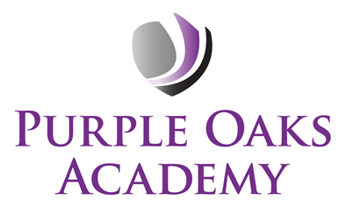

Relationships and Sex Education Policy

Version: | 2.0
Document Author: | Sonia Iancu
Classification:
Created: | Sep 2025
Review Date: | Sep 2026

Contents
- Values and Ethos 3
- Aims 3
- Statutory Requirements 4
- Definition 5
- Curriculum Design 6
- Delivery of RSE 8
- Roles and Responsibilities 8
- Safeguarding 9
- Parents’ right to withdraw 9
- Training 10
- Monitoring Arrangements 10
- Assessment 10
Appendices
Appendix 1: Parent Form: withdrawal from sex education within RSE 18
Appendix 2: Right to Withdrawal - DfE Summary 20

Values and Ethos

All schools must provide a curriculum that is broadly based, balanced and meets the needs of all pupils. Under section 78 of the Education Act 2002 and the Academies Act 2010, a PSHE( Relationship and Health Education and Relationship and Sex Education) curriculum:
- Promotes the spiritual, moral, cultural, mental and physical development of pupils at the school and of society, and
- Prepares pupils at the school for the opportunities, responsibilities and experiences of later life.

Aims
The aim of Purple Oaks’ PSHE Curriculum is to provide children with age-appropriate information, explore attitudes and values and develop skills to empower them to make positive decisions about their health-related behaviour. Knowledge about safer sex and sexual health remains important to ensure that young people are equipped to make safe, informed and healthy choices as they progress through adult life.
Statutory RSE and Health Education
“The Relationships Education, Relationships and Sex Education and Health Education (England) Regulations 2019, made under sections 34 and 35 of the Children and Social Work Act 2017, make Relationships and Sex Education compulsory for all pupils receiving secondary education… They also make Health Education compulsory in all schools except independent schools. Personal, Social, Health and Economic Education (PSHE) continues to be compulsory in independent schools.”
DfE Guidance p.8.
We define 'relationships and sex education' as a curriculum which will help our children grow in confidence and understanding relating to how they as individuals will develop, grow and mature into responsible individuals.
  - We believe relationships and sex education is important for our academy because it will help our children to value positive relationships and to have the confidence and strength of character to identify and lead a healthy lifestyle.
  - We view the partnership of home and academy as vital in providing the context of open discussion, honesty and support.

The intended outcomes of the programmes of study are that pupils will:
    - Know and understand, how as individuals our bodies change as we get older.
    - Understand they have the right to be safe.
    - Understand they have a responsibility to be a responsible, valued member of the academy.
    - Develop the skills needed to lead a healthy lifestyle.
    - Develop the attributes of positive relationships.

Statutory Requirements & Legislation

The Greenwood Academies Trust follows the Department for Education statutory guidance that was statutory from September 2020. The guidance states which academies need to deliver relationships education, sex education and health education and what the RSE policy should include:
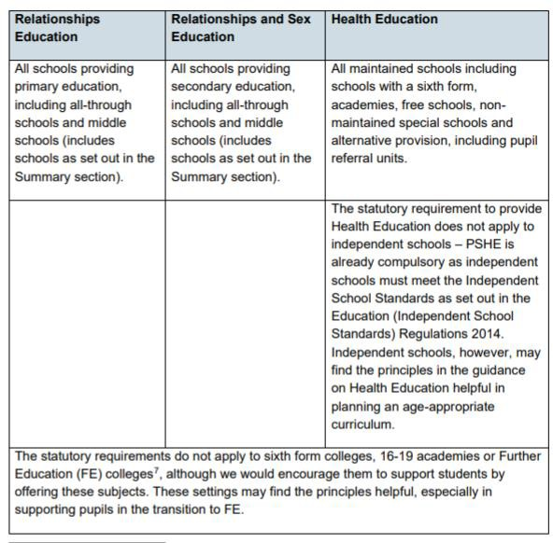

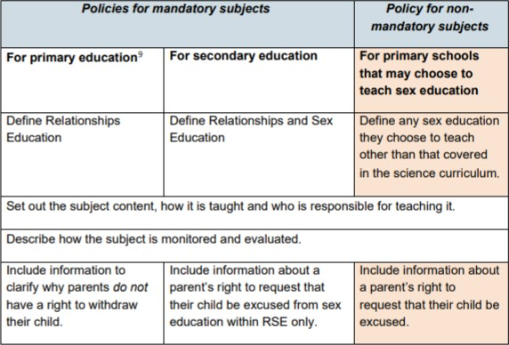

Documents that inform the Trust's RSE policy include:
- Education Act (1996)
- Learning and Skills Act (2000)
- Education and Inspections Act (2006)
- Equality Act (2010)
- Locally Agreed RE Syllabus in line with SACRE Guidelines
- Supplementary Guidance SRE for the 21st Century
- Keeping Children Safe in Education – Statutory safeguarding guidance
- As an academy we must provide relationships education to all pupils as per section 34 of the Children and Social work act 2017.
- Equals Curriculum

Definition

RSE teaches children and young people how to be safe and healthy. It teaches them how to manage their academic, personal and social lives in a positive way. RSE involves a combination of sharing information, exploring issues and values. RSE is not about the promotion of sexual activity or lifestyles.

Relationships Education: the focus is on teaching the fundamental building blocks and characteristics of positive relationships, with particular reference to friendships, family relationships, and relationships with other children and with adults. These areas of learning are taught within the context of family life taking care to ensure that there is no stigmatisation of children based on their home circumstances (families can include single parent families, LGBT parents, families headed by grandparents, adoptive parents, foster parents/carers amongst other structures) along with reflecting sensitively that some children may have a different structure of support around them (for example: looked after children or young carers).

Health Education: the focus is on teaching the characteristics of good physical health and mental wellbeing. Teachers should be clear that mental wellbeing is a normal part of daily life, in the same way as physical health.

Sex Education: The DfE Guidance 2019 integrates Relationships and Sex Education at secondary school level.
Most of the DfE outcomes relating to Sex Education sit withing the ‘Intimate and sexual relationships, including sexual health’ section of the guidance and include aspects like:
• the facts about reproductive health…
• the facts about the full range of contraceptive choices …
• how the different sexually transmitted infections (STIs), including HIV/AIDS, are transmitted…
• how to get further advice…
• consent and the law
DfE Guidance page29.
At Purple Oaks Academy we agree with the Sex Education Forum definition of Sex Education (as above).

Parents have the right to withdraw a pupil from sex education lessons up to three months before the 16th birthday of the pupil when the child can choose to opt in.

Curriculum Design

Our curriculum planning is aligned with the Planning Framework for Pupils with SEND, the Interoception Curriculum, and individual Education, Health and Care Plan (EHCP) and Individual Education Plan (IEP) targets. This approach ensures that learning experiences are tailored to meet the diverse needs of our pupils with SEND, supporting their sensory processing and emotional regulation through the Interoception Curriculum. By focusing on personalized EHCP and IEP targets, we provide clear, measurable goals that guide teaching and assessment, promoting meaningful progress for each student. These frameworks reflect the specific requirements and strengths of our learners, offering a more relevant and effective pathway for their personal, social, and emotional development.

The Planning Framework for Pupils with SEND is fully aligned with the Statutory Guidance for Relationships Education, Relationships and Sex Education and Health Education (RSHE).

The curriculum content for KS1 and KS2 includes:
- Self-Awareness
- Self-Care, Support and Safety
- Managing Feelings
- Changing and Growing
- Healthy Lifestyles
- The World I Live In

The curriculum content for KS3, KS4 and KS5 includes:

- Self-Awareness
- Self-Care, Support and Safety
- Managing Feelings
- Changing and Growing
- Healthy Lifestyles
- The World Live In

The Interoception Curriculum is organised to help students develop an awareness of their internal body signals (interoception), recognise their feelings, and learn effective strategies for managing these emotions and physical sensations. It provides structured activities and learning objectives that guide students through understanding how bodily sensations relate to emotions and behaviours, promoting self-regulation and emotional wellbeing. This curriculum supports our students by enhancing their ability to identify internal cues, such as hunger, thirst, anxiety, or calmness, and by teaching them practical techniques to respond appropriately, thereby improving their overall self-awareness and coping skills.

The Pathway 3 and 4 students in KS4 will be studying the BTEC Level 1 Certificate in Personal Growth and Wellbeing. This course is designed to support their development in areas such as physical health, emotional wellbeing, personal rights, and environmental impact, tailored to their learning needs. It provides practical and accessible learning experiences that help students build essential life skills and prepare for the next steps in education, employment, or independent living.

Relationships Education and Health Education are compulsory subjects and parents/carers do NOT have the right to withdraw their children from these subjects.

The aim of RSE is to give young people the information they need to help them develop healthy, nurturing relationships of all kinds, not just intimate relationships. It should enable them to know what a healthy relationship looks like and what makes a good friend, a good colleague and a successful marriage or other types of committed relationships. It also covers contraception, developing intimate relationships and resisting pressure to have sex/not applying pressure to have sex. It should teach what is acceptable and unacceptable behaviour in relationships. This will help students understand the positive effects that good relationships have on their mental well-being, identify when relationships are not right and understand how such situations can be managed.

Parents/carers have the right to request that their child be withdrawn from some or all of sex education delivered as part of statutory RSE (but cannot withdraw their child from Relationships or Health Education).

Delivery of RSE
RSE is taught within the personal, social, health and economic (PSHE) education curriculum every week.
At KS3 onwards, pupils also receive sex education lessons, and these are optional at KS2 – see the table on page 4 for the DfE requirements.

Roles and Responsibilities

The Trust
The Trust has a set of activities that will monitor the quality and effectiveness of the RSE policy and curriculum in each academy. The Curriculum Assurance Board will be key to the monitoring of this policy and will develop additional support or guidance to academies if required.

The Purple Oaks Academy
The principal is responsible for ensuring that RSE is taught consistently across the academy, and for managing requests to withdraw pupils from non- statutory/non-science components of Sex Education. The principal is responsible for ensuring policy and practice are adhered to and that all information is made accessible to all parents and carers.

- The nominated person for PSHE is responsible for development of the curriculum and monitoring of the curriculum across the academy.
- It will be taught by teachers in each year group.
- Teachers will receive RSE training as appropriate.
The principal should also ensure that there has been consultation with the academy community and parents/carers on the policy and curriculum for RSE in line with the guidance from the DfE. The academy should ensure this also published on the website.

Staff
Staff are responsible for:
Delivering RSE in a sensitive way
Modelling positive attitudes to RSE
Monitoring progress
Responding to the needs of individual pupils
Responding appropriately to pupils whose parents wish them to be withdrawn from the non-statutory/non-science components of Sex Education

Staff do not have the right to opt out of teaching RSE. Staff who have concerns about teaching RSE are encouraged to discuss this with the Principal. All class teachers are responsible for teaching RSE.

Pupils
Pupils are expected to engage fully in RSE and, when discussing issues related to RSE, treat others with respect and sensitivity.

Safeguarding
Academies must consider how safeguarding and confidentiality protocols support safe and effective RSE practice.
- Teachers should be aware of the academy confidentiality policy.
- Teachers are aware that effective RSE, which brings an understanding of what is and what is not appropriate in a relationship, can lead to a disclosure of a child protection issue.
- Teachers will consult with the designated safeguarding lead who will follow academy policy for safeguarding.
- Visitors/external agencies which support the delivery of RSE will be required to adhere to academy safeguarding policies, confidentiality and the RSE policy.

Parents’ right to withdraw
Parents do not have the right to withdraw their children from relationships education. Parents have the right to withdraw their children from the non-statutory/non-science components of sex education within RSE.
Requests for withdrawal should be put in writing (optional form can be found at Appendix 2 and addressed to the Principal) or fill in the form https://forms.office.com/e/87ZtF49kY2

The trust would expect the Principal to honour appropriate requests for withdrawal and meet with parents to discuss these in line with the DfE guidance as summarised in Appendix 3. Alternative work will be given to pupils who are withdrawn from sex education.

Training
Staff are to be trained on the delivery of RSE.
The Principal may also invite visitors from outside the school, such as school nurses or sexual health professionals, to provide support and training to staff teaching RSE.

Monitoring Arrangements
The delivery of RSE is monitored in academies by senior leaders through activities such as planning scrutinise, lesson visits, children and staff surveys
Pupils’ development in RSE is monitored by class teachers as part of internal assessment processes.

The implementation of this policy is monitored by the Trust through:
  - Assurance activities to ensure statutory arrangements are in place in each academy
  - Assurance activities to ensure the academy policies are being implemented and the RSE curriculum in each academy is of sufficient quality
  - This policy will be reviewed regularly, and the Curriculum assurance Board will lead the development of any amendments to the policy.

Assessment
There are many reasons why it is important that learning in PSHE, including RSE, is assessed, including:

- Pupils need opportunities to reflect on their learning and its implications for their lives.
- Teachers need to know that learning has taken place, be able to demonstrate progress and identify future learning needs.
- Assessment increases pupils’ motivation and improves learning, as their raised awareness of their progress illustrates the value of this learning.
- Assessment allows the leadership team, parents, governors and school inspectors to see PSHE education’s impact on pupils and whole school outcomes, such as Ofsted judgements on personal development, safeguarding, spiritual, moral, social and cultural (SMSC) development and the promotion of fundamental British values.
- Without assessment, all a school can do is describe its PSHE provision, not show its impact.
- The DfE also states in the statutory guidance for Relationships, Sex and Health education that “schools should have the same high expectations of the quality of pupils’ work in these subjects as for other curriculum areas” — therefore assessment for and of learning should be central to any PSHE education provision.

At the Purple Oaks Academy
- Pupils will be provided with time to discuss and share their thoughts and feelings appropriately
- Adults will be expected to respond to pupil needs through follow up work that could be whole class, small group or 1:1.
- Pupils will have opportunities to review and reflect on their learning through activities including reflection time, discussion, written work and artwork.
- Pupil voice and assessment will be used to adapt and amend planned learning activities
- Parents will be informed of pupil understanding in the usual ways including via parent consultations and written reports.

References and Sources
The following have been referenced during the development of this policy:
- The PSHE Association for the POS and Overview Documents
- Department for Education guidance for Relationships Education, Relationships and Sex Education (RSE) and Health Education
- Equalities Act 2010
- Keeping Children Safe in Education
- Interoception Curriculum
- PSHE association - Planning Framework for Pupils with SEND
- BTEC Level 1 - Personal Growth and Wellbeing (Level 1)

Appendix 1: Parent Form
TO BE COMPLETED BY PARENTS

Purple Oaks Academy Withdrawal from Sex Education
Name of Child: |  | Class:
Name of Parent: |  | Date:
Reason for withdrawing from sex education:
Any other information you would like the school to consider:
Parent signature:

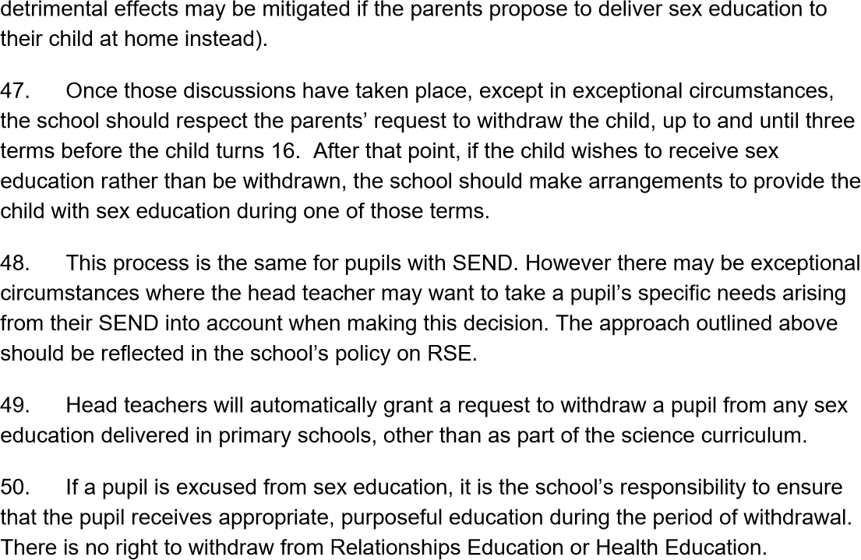
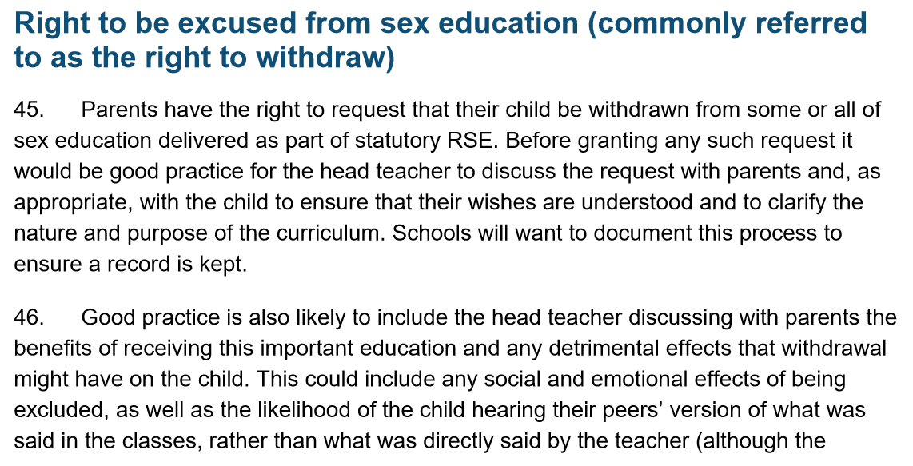
Appendix

