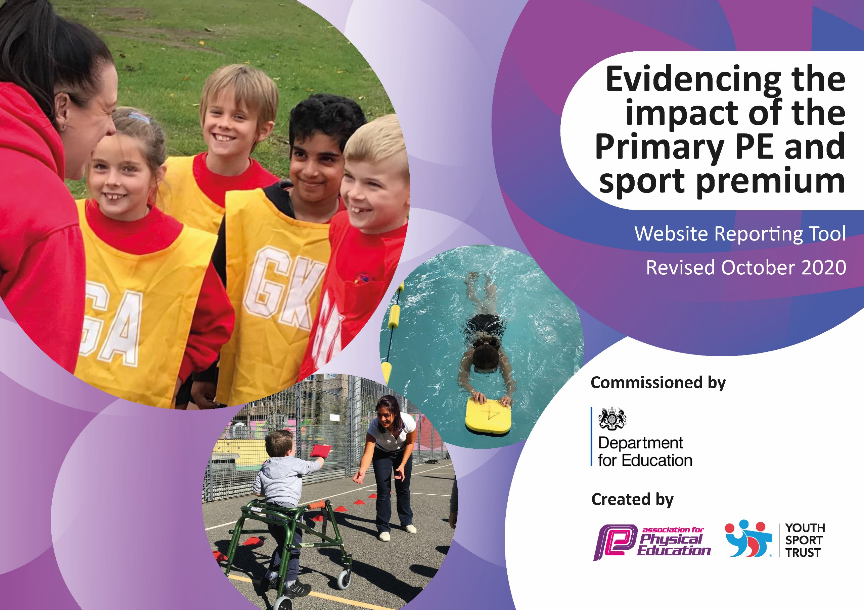
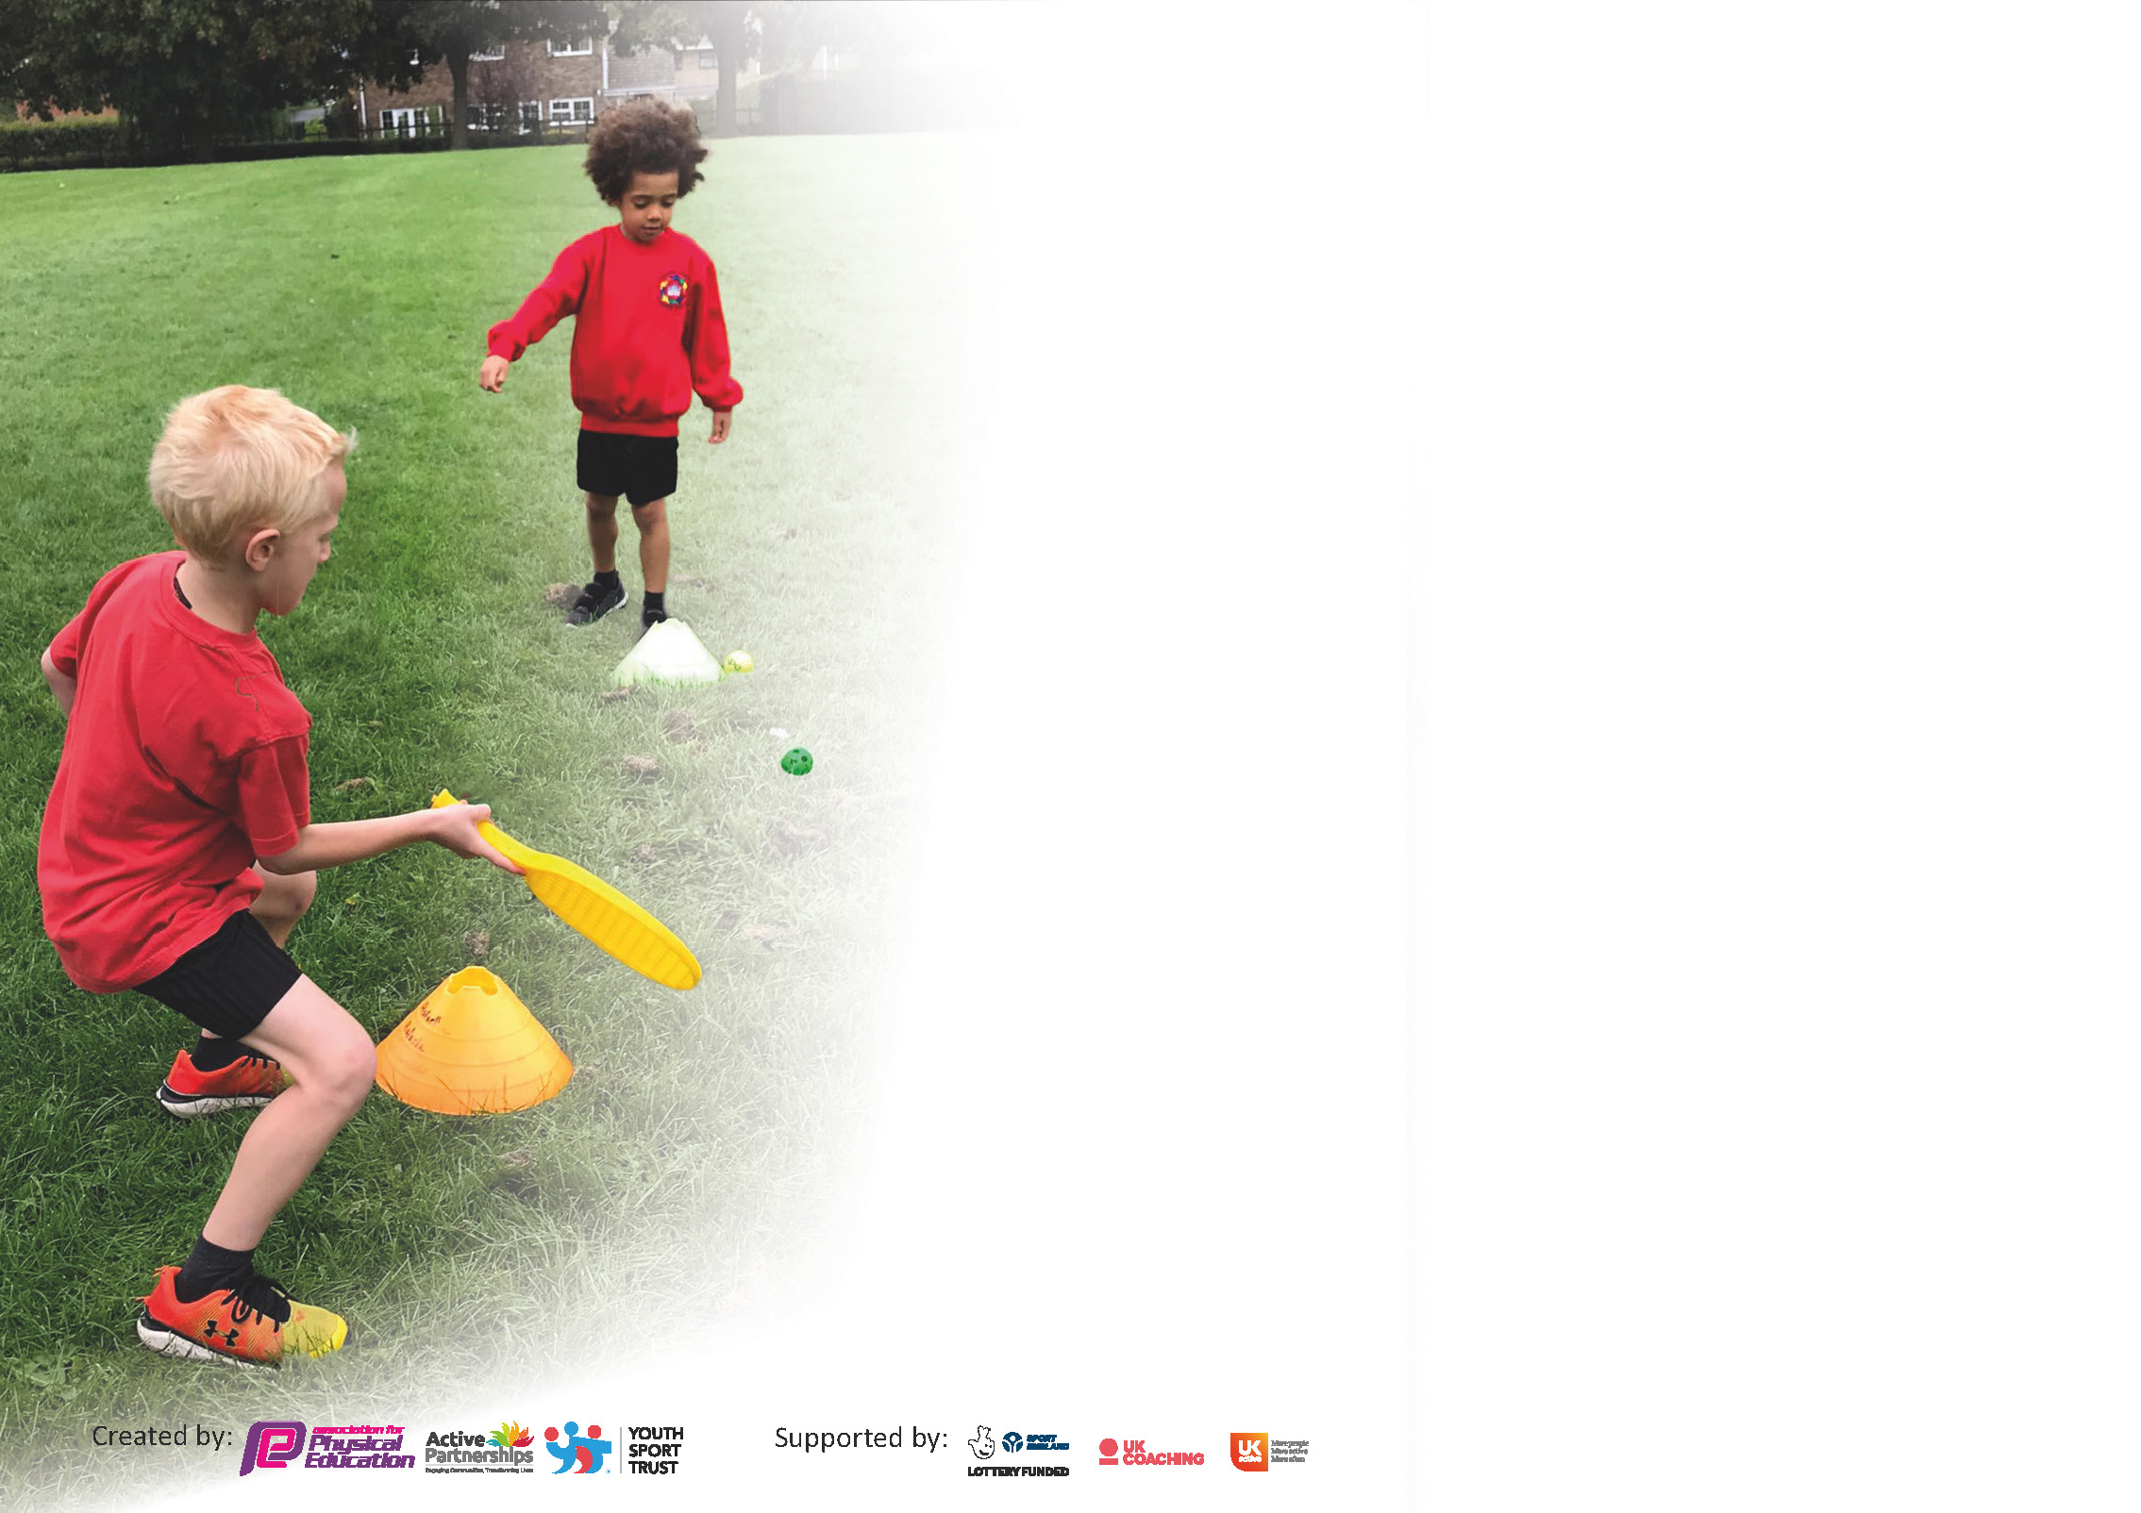

It is important that your grant is used effectively and based on school need. The Education Inspection Framework (Ofsted 2019 p64) makes clear there will be a focus on ‘whether leaders and those responsible for governors all understand their respective roles and perform these in a way that enhances the effectiveness of the school’.

Under the Quality of Education criteria (p41) inspectors consider the extent to which schools can articulate their curriculum (INTENT), construct their curriculum (IMPLEMENTATION) and demonstrate the outcomes which result (IMPACT).

To assist schools with common transferable language this template has been developed to utilise the same three headings which should make your plans easily transferable between working documents.

Schools must use the funding to make additional and sustainable improvements to the quality of Physical Education, School Sport and Physical Activity (PESSPA) they offer. This means that you should use
the Primary PE and sport premium to:

- Develop or add to the PESSPA activities that your school already offer
- Build capacity and capability within the school to ensure that improvements made now will benefit pupils joining the school in future years

Please visit gov.uk for the revised DfE guidance including the 5 key indicators across which schools should demonstrate an improvement. This document will help you to review your
provision and to report your spend. DfE encourages schools to use this template as an effective way of meeting the reporting requirements of the Primary PE and sport premium.

We recommend you start by reflecting on the impact of current provision and reviewing the previous spend.

Schools are required to publish details of how they spend this funding as well as on the impact it has on pupils’ PE and sport participation and attainment by the end of the summer term or by 31st July 2021 at the latest.

** In the case of any under-spend from 2019/20 which has been carried over this must be used and published by 31st March 2021.

We recommend regularly updating the table and publishing it on your website throughout the year. This evidences your ongoing self-evaluation of how you are using the funding to secure maximum, sustainable impact. Final copy must
be posted on your website by the end of the academic year and no later than the 31st July 2021. To see an example of how to complete the table please click HERE.
Created by: Supported by:

Please note: Although there has been considerable disruption in 2020 it is important that you publish details on your website of how you spend the funding - this is a legal requirement.
Support for review and reflection - considering the 5 key indicators from DfE, what development needs are a priority for your setting and your pupils now and why? Use the space below to reflect on previous spend and key achievements and areas for development.

N.B. In this section you should refer to any adjustments you might have made due to Covid-19 and how these will influence further improvement.
Key achievements to date until July 2020: | Areas for further improvement and baseline evidence of need:
- Training of staff – use of Premier Sports to provide high quality training to teachers in order to upskill their knowledge of the curriculum, in gymnastics and dance  - MOT training for all staff  - Raising profile of Sport through the increased participation in competitions  - Increased participation of a wide range of extra-curricular clubs throughout the year | 1)Build upon CPD already taken place for staff to ensure highest quality outcomes for our children – linked to Staff voice last academic year  2) Further develop and additional competitive sports and club opportunities across the school  3) Ensure all children have the opportunity to engage in 30 minutes a day healthy, physical activity in school by embedding the role of Young Leaders  4) Ensure that the percentage of children in Year 6 is in line with the national percentage of children who are achieving the national curriculum requirements for swimming and water safety, focusing on a broad range of strokes  5) Continue to raise the profile of PE throughout the school and the local community

Did you carry forward an underspend from 2019-20 academic year into the current academic year? YES

If YES you must complete the following section
If NO, the following section is not applicable to you

If any funding from the academic year 2019/20 has been carried over you MUST complete the following section. Any carried over funding MUST be spent by 31 March 2021.
Academic Year: September 2020 to March 2021 | Total fund carried over:  £1,740 | Date Updated:  20/07/2021  covered 17.4% of Premier Education invoices
What Key indicator(s) are you going to focus on? |  |  |  | Total Carry Over Funding:
 |  |  |  | £ 1, 740
Intent | Implementation |  | Impact
Your school focus should be clear how you want to impact on your pupils. | Make sure your actions to achieve are linked to your intentions: | Carry over funding allocated: | Evidence of impact: How can you measure the impact on your pupils; you may have focussed on the difference that PE, SS & PA have made to pupils re-engagement with school. What has changed?: | Sustainability and suggested next steps and how does this link with the key indicators on which you are focussing this academic year?:

Meeting national curriculum requirements for swimming and water safety.  N.B Complete this section to your best ability. For example you might have practised safe self-rescue techniques on dry land. | Incomplete data due to Covid-19
What percentage of your current Year 6 cohort swim competently, confidently and proficiently over a distance of at least 25 metres?  N.B. Even though your pupils may swim in another year please report on their attainment on leaving primary school at the end of the summer term 2020. | %  N/A
What percentage of your current Year 6 cohort use a range of strokes effectively [for example, front crawl, backstroke and breaststroke]? | %  N/A
What percentage of your current Year 6 cohort perform safe self-rescue in different water-based situations? | %  N/A
Schools can choose to use the Primary PE and sport premium to provide additional provision for swimming but this must be for activity over and above the national curriculum requirements. Have you used it in this way? | Yes/No

Action Plan and Budget Tracking
Capture your intended annual spend against the 5 key indicators. Clarify the success criteria and evidence of impact that you intend to measure to evaluate for pupils today and for the future.

Academic Year: 2020/21 | Total fund allocated: £ 16,240 | Date Updated: 19/07/2021
Key indicator 1: The engagement of all pupils in regular physical activity – Chief Medical Officers guidelines recommend that primary school pupils undertake at least 30 minutes of physical activity a day in school |  |  |  | Percentage of total allocation:
 |  |  |  | %
Intent | Implementation |  | Impact | 14.8%
Your school focus should be clear what you want the pupils to know and be able to do and about  what they need to learn and to  consolidate through practice: | Make sure your actions to achieve are linked to your intentions: | Funding allocated: | Evidence of impact: what do pupils now know and what can they now do? What has changed? | Sustainability and suggested next steps:
1. Develop a Healthy Active Engagement Programme to encourage more children to engage more regularly in additional physical activity  opportunities | 1. Ensure the all the students have opportunity to engage in 30 minutes a day healthy, physical activity  • Embed use of “ 5 a day” across the school  • Promote the use of “ 5 a day” during wet play, PE warm ups  • New strand to the resource allows pupils and parents to access it at home  2. Continue to provide a range of lunch time and after academy sports clubs to support enrichment and the increase of vigorous physical activity, alongside developing social skills. ( lunch time activities postponed until January 2021)  • Premier Sports Coaches to provide lunchtime clubs 2X lunchtimes and then 2X after academy club  3. Young pleaders to provide additional physical activity opportunities  • Timetable play leaders and give them ownership of activities to be run at play times  • Young leaders to work alongside Premier sport coach at lunch time to encourage students to participate in a wider range of sports  • Young leaders to support in the development of interschool competitions  4. Sensory circuits  • Each class has 30 minutes access to sensory circuits focused on needs of particular students  - Acquisition of new sensory equipment for each bubbles  5. New PE equipment to encourage different types of sports and cross-curriculum activities | £2400  ( GAT package)  £ 2650  £500  £ 1700 | Evidence:  • Club registers  • Photographs  • Pupil voice  • ‘5 a day’ participation record Impact/  Outcomes for children:  - Wider knowledge and understanding of a range of different sports  - Greater understanding of how to keep themselves fit and healthy (body and mind)  - Wider opportunities to engage in different types of sport  - Increased number of students participating in academy clubs  - Students are accessing structured, healthy physical activity at lunchtimes.  - Students show more awareness of their bodies and improved spatial awareness. Sensory needs are being met therefore behaviour will be better regulated.  - Each bubble has its own sensory circuit equipment  - Acquisition of different PE equipment to encourage the students to take part in different types of sports  - ( archery, badminton, cycling, tennis, new age curling)  - New PE equipment to encourage cross curriculum activities ( Active Maths, Science) | Due to Covid-19 restrictions and lockdown, no afterschool clubs or lunch time activities have been provided  Students have access to bikes / climbing equipment on a rota basis to maintain the integrity of the bubbles.  To replace the lack of the lunch activities and ensure that students have access to physical activities throughout the day, an extra break has been added in the afternoon.  The lunch time activities budget will be carried forward to the next year.  During breaks, the Young Leaders encouraged the other students to play team games such as: basketball, football and rugby.  EYFS had access to soft play area.  Lower Phase -Students had access to their own sensory circuit  Middle phase - Students had access to their own sensory circuit  Acquisition of a new PE equipment: badminton, tennis, basketball, New Age Curling, Boccia, dodgeball, sensory circuit equipment - PE budget
Key indicator 2: The profile of PESSPA being raised across the school as a tool for whole school improvement |  |  |  | Percentage of total allocation:
 |  |  |  | %
Intent | Implementation |  | Impact | 0%
Your school focus should be clear what you want the pupils to know and be able to do and about  what they need to learn and to  consolidate through practice: | Make sure your actions to achieve are linked to your intentions: | Funding allocated: | Evidence of impact: what do pupils now know and what can they now do? What has changed?: | Sustainability and suggested next steps:
- Support the development of the whole child through the achievement of whole academy outcomes as a result of a focus on PE, School Sport and Physical Activity | - Ensure PE and Sports Premium are embedded within the whole school SIP  - In school guidance to review, plan and meet the requirements of the PE&Sport Premium funding  - Develop the profile of PE through whole school displays which celebrate the curriculum, students’ achievements and links to other curriculum areas  - Display boards to promote the range of: sports taught in school, clubs on offer, competitions entered  - Displays to showcase links with other areas of the curriculum  - Celebrations to be shared in the school’s newsletter, on the website and on twitter  Use staff and pupil voice to develop the needs of the school | Internal budget | - Greater understanding of how PE & Sport Premium can support achievement of whole-academy priorities and outcomes for children  - Key Strategic Actions Identified which will have the greatest, most sustainable outcomes for our children  - 30 Minute strategies in place and enhanced engagement in lessons  - Improved engagement in PE lessons and enhanced development of personal and social skills and behaviour | - To provide staff with training to ensure the PE lessons are good and outstanding  • To carry on with Staff  questionnaires and pupil  voices  • To involve parents to take  part/attend in different  sports events. (parents got involved with the online PE sessions)  - Parents involved in the Mencap All Move programme  - End of the year PE Newsletter

Key indicator 3: Increased confidence, knowledge and skills of all staff in teaching PE and sport |  |  |  | Percentage of total allocation:
 |  |  |  | %
Intent | Implementation |  | Impact | 51 %
Your school focus should be clear | Make sure your actions to | Funding | Evidence of impact: what do | Sustainability and suggested
what you want the pupils to know | achieve are linked to your | allocated: | pupils now know and what | next steps:
and be able to do and about | intentions: |  | can they now do? What has
what they need to learn and to |  |  | changed?:
consolidate through practice:
- Improve the progress and achievement of all children by increasing staff knowledge, skills, understanding and confidence to deliver outstanding PE, School Sport and Physical Activity | - Staff CPD Programme – engage Allison Consultancy to provide further CPD to enhance the delivery of PE  2. Engage Premier Sports to work alongside and provide the following in-school support for staff throughout the whole school  • Working alongside all teachers with the students to plan and deliver high quality lessons across curriculum  3. CPD for the PE Leader  • Access a series of Central CPD days tailored to PE leaders and designed to support the enhancement of the PE curriculum.  • Disseminate key information and training to teaching staff throughout the academy.  4. Purchase the “Sport Plan” resource.  • 14,000 creative ideas across 18 sports. Each drill has an animated diagram, full explanation and progressions.  • 500 tried and tested ready to go lesson plans.  5.Academy Staff CPD Audit * PE coordinator to conduct an audit of Staff PE CPD needs | Part of GAT package  £10,010  Part of Gat package  Part of GAT package | Evidence  • In-school 3 training days from Allison Consultancy taking place (TBA)  • New PE Curriculum Map in place  • All DfE / Ofsted On-line reporting requirements for PE & Sport Premium complete  • Enhanced student progress and attainment data for PE available  • Lesson Observations / PE Learning walks  • Discussions with staff  • PE Lead accessing and monitoring assessments across the academy  Impact / Outcomes for staff:  • A more focused action plan to enhance standards of provision incorporating greater sources of evidence and increased impact / outcome statements for both staff and children  • Greater understanding of National Curriculum PE, what is currently being provided and key actions to enhance and develop planned provision  • PE Curriculum extended  • Clearer understanding of 30 Minute a Day requirement  • Teachers using lesson plans – increased confidence, knowledge and understanding to deliver more effective PE lessons  • Increased confidence in making and recording assessments in PE  • This will support enhanced planning and delivery of PE lessons based on targeted needs of our children  • Sustainability: new resource in place and can be used year on year  • Academy can track and monitor children’s progress and attainment against national age-related expectations and target intervention and support for staff and children where required  • Improved assessment and monitoring  • Assessments in PE (including swimming) are clear and accurate, with input from teacher and coach  • PE Lead upskilled and ready to support implementation of PE assessment system  Impact / Outcomes for children:  • Effective use of the funding leading to enhanced PESSPA provision and opportunities for children  • Key Strategic Actions Identified ensuring the greatest, most sustainable outcomes for our staff and children  • Children learning through all areas of PE as required by the National Curriculum  • Children receive a broad and balanced offer within and beyond the curriculum  • Children engaged in enhanced, more effective PE lessons  • Enhanced student understanding of and learning across all four areas of National Curriculum PE | - In-school trainings have been suspended due to Covid-19 restrictions and the OP and RA put in place  - Staff has given positive feedback about the Sports coach  - Termly meeting with the  director of the company which supplies the sports coaches to maintain the high standards of services provided  - Three in-house Pe trainings for the PE leader delivered by Gat and Alison Consulting  - To ensure teachers are working alongside coaches, including being involved in the planning and assessments  - • To ensure the scheme of work is shared and provided to teachers, help them plan and teach in progression of skills  During the current academic year there were three PE staff meetings  PE lead shared the intent, implementation and the impact of the PE curriculum  During lockdown, the PE leader shared with all staff different Physical activities websites to ensure that the students will stay active at home.  Home physical challenges were shared with all teachers
Key indicator 4: Broader experience of a range of sports and activities offered to all pupils |  |  |  | Percentage of total allocation:
 |  |  |  | %
Intent | Implementation |  | Impact | 0%
Your school focus should be clear | Make sure your actions to | Funding | Evidence of impact: what do | Sustainability and suggested
what you want the pupils to know | achieve are linked to your | allocated: | pupils now know and what | next steps:
and be able to do and about | intentions: |  | can they now do? What has
what they need to learn and to |  |  | changed?:
consolidate through practice:
Additional achievements:  - Increase the range of activity opportunities outside the curriculum in order to get more students involved. | - Increase the balance-ability/ bike ability offer through local council initiative.  - Young pleaders to provide additional physical activity opportunities  - Timetable play leaders and give them ownership of activities to be run at play times  - Young leaders to work alongside Premier sport coach at lunch time to encourage students to participate in a wideityr range of sports  - Young leaders to support in the development of interschool competitions  - Sensory circuits  - Each class has 30 minutes access to sensory circuits focused on needs of particular students  - Provide opportunities for students to try a wide range of sports through the use of external expertise  - Taster sessions  - Organize a whole school national sports week event  - Students given opportunities to try new physical activities through Northamptonshire Inclusive Sports and GAT Sports events. | £ 150  Internal Budget  £ 500 | 1) Bike ability offered to KS1 and 2 students to help them increase their physical skills. Funding stream from local council to support engagement in this.  Students across KS1/KS2 engage in appropriate sporting events and competitions to increase their physical skills and understanding of sportsmanship.  Evidence  • All programmes in place and students engaging on a regular basis  • 30 Minutes a Day activity timetabled in for every class  • New equipment purchased and used  • Widened range of healthy activity opportunities  • Extended Extra-Curricular Sport and Physical Activity Programme as Wheelchair rugby  • Participation Registers  • Increased number of students participating in academy clubs  • PE, School Sport and Physical Activity (PESSPA) noticeboard updated  • Pupil voice surveys  • Staff voice  Impact / Outcomes for Children:  • Increased awareness of the wide range of different types of healthy activity available  • Increased opportunities for healthy activity available  • Increased engagement in exercise  • Increased understanding of the benefits of exercise for health  • Improvement in sense of health and well-being  • Increased participation by children who normally don’t engage with sporting / physical activity opportunities  • Increased number of children enjoying taking part in academy clubs | Booked for January – National lockdown  It has to be rescheduled for 28th and 29th September 2021  Young leaders worked alongside the Sports coach  Young leaders have the opportunity to lead warm up sessions  New Age Curling training sessions for young Leaders had to pe postponed due to National Lockdown  - Middle Phase students took part in free Ultimate Frisbee Workshop  - Upper Phase students took part in free Mencap All Move programme  - The aim of the programme is to increase the opportunities for young people with a learning disability and autism to get physically active, aiming to improve their physical and mental wellbeing.  - The next Mencap programme will start on 1st November 2021 for 20 weeks  - 12 students from Upper Phase took part in free rugby sessions delivered by Northampton Saints  - GAT events rescheduled for 2021-2022

Key indicator 5: Increased participation in competitive sport |  |  |  | Percentage of total allocation:
 |  |  |  | %
Intent | Implementation |  | Impact | 0%
Your school focus should be clear | Make sure your actions to | Funding | Evidence of impact: what do | Sustainability and suggested
what you want the pupils to know | achieve are linked to your | allocated: | pupils now know and what | next steps:
and be able to do and about | intentions: |  | can they now do? What has
what they need to learn and to |  |  | changed?:
consolidate through practice:
- To introduce additional, inclusive competitive sports opportunities providing the opportunity for all children to participate | 1. GAT Programme  • Access to GAT competitions  • Supply cover for staff to attend both the above.  2. Participate in an increased range of competitive  Opportunities against self and others  • Northamptonshire Inclusive Sports  • Inclusive PE sports  • Young leaders training and delivery sessions  • School Games Mark – Achieve silver  • GAT Sports events.  • Develop intra school competitions using young leaders | £100  Postponed until Feb 2021  £300 | Evidence  - PE Units of Work developed to include competitive opportunities  - New Sports and physical activity competitive opportunities in place  - Participation Registers  - Resources to plan and deliver programme  Impact / Outcomes for staff:  - Sustainability – Teaching Staff able to deliver competitive sport / physical activity with their children in lessons  Leading to the following outcomes accessible by all students.  Increased student:  - Experience of competition against self and others  - Virtual School Games  - Experience and understanding of rules and scoring systems  - Experience and understanding of how to work as a team and how to handle winning and losing and the importance of good sportsmanship  - Confidence  - Enjoyment of sport across the academy  - Opportunities to participate in a wider variety of activities  - Awareness of the importance of physical activity and health  - Socialisation with other children from other academies/ backgrounds  Experience of sense of well-being and the feeling of achieving their best | - GAT events rescheduled for academic year 2021-2022  - Middle Phase students took part in an Ultimate Frisbee Workshop  - Upper Phase students  - Took part in Mencap All Move programme  - 12 students from Upper Phase took part in rugby sessions delivered by Northampton Saints

Signed off by
Head Teacher:
Date:
Subject Leader: | Sonia Iancu
Date: | 20.07.2021
Governor:
Date:
Fund carried over from 2019-2020 - £ 1,740 – used to cover 17.4% of Premier Education invoices

Fund 2020-2021 - £ 16,240 – total spent - £10,670 – 65.8 %

Fund carried over - £5,570

